Hi Sunny –

Please see the below feedback for the charts from the other day…

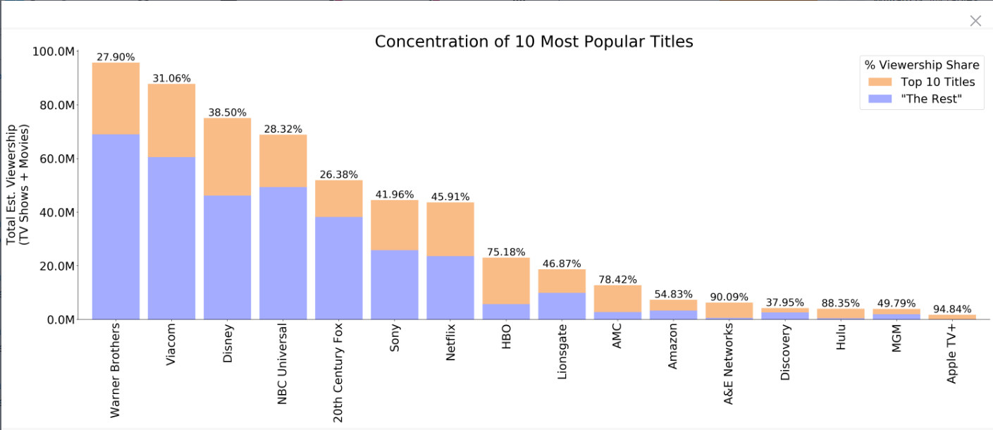

Perfect – looks good!

Quick question on the stacked bar / pie chart… is it possible to cut off the connecting lines approximately 80-85% of the distance? (see image below)

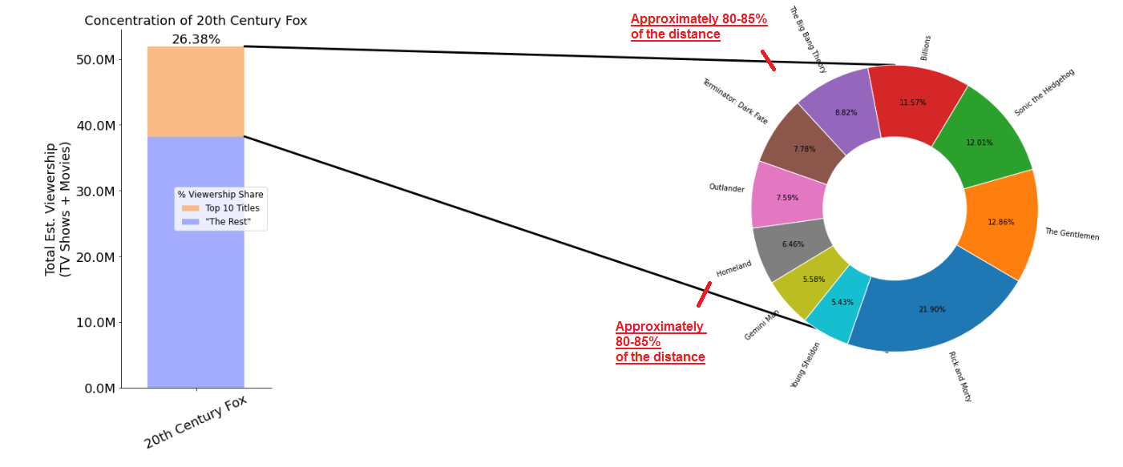

I feel this may enhance the graph by preventing the lines from interfering as much with the pie graph while still accomplishing the visual representation that the two graphs are related.

Pie graph / double bar graph

Can the double bar graph be converted to one where there are two y-axis? In this scenario, one side would display ticks for “Total Returns” and the other side would display for “System Quality Number”.

The reason why its relevant to have two y-axis is because System Quality Number should not be multiplied by 100 (its fundamentally not a percent value). So the original values that typically range between approximately -3 through 6 are accurate in their original form. I created a quick visual representation below showing two y-axis:

